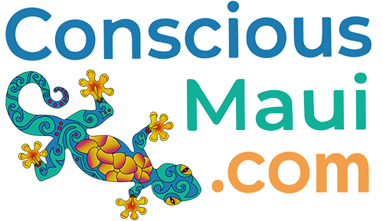
PO Box 790443
Paia, HI. 96779

November 16, 2018

For Immediate Release

New resource for conscious businesses launches on Maui

ConsciousMaui.com offers businesses free listings in its new online guide

Paia, Hawaii – A new online resource designed specifically for Maui's environmentally- and culturally-conscious community recently launched at ConsciousMaui.com. The website is a guide to conscious businesses, services, activities and events on the Valley Isle; it also features a blog, guide to volunteer opportunities, a curated surf & weather report and more.

ConsciousMaui.com launched with more than 300 plus listings (provided at no cost) whose main operating objectives fall under these general categories: Eco-friendly and Sustainable, Alternative Health and Wellness, Preservation and Conservation, Culturally Significant/Hawaiian, Non Profit and Volunteerism. The site has created an easy-to-use color-coded “Gecko Guide” to make it simple for the consumer to identify what category applies to each listing.

“Our aim was to create an easy to use, clear way for locals and visitors to support those businesses and events that are helping Maui be sustainable,” said ConsciousMaui.com founder Hoku.

At the time of launch, the site featured a variety of listings including activities; alternative health and wellness; animals; culturally significant/Hawaiian; food; home and business; non-profits; products; and rentals. The categories will likely grow as new listings are added each week. The site also features a page for volunteer opportunities that were designed to benefit not only the local community but visitors who increasingly look for opportunities to give back when they travel.

“The Hawaii Tourism Authority did a study last year and noted that visitors were wanting to come to Maui for more than beaches and resorts,” Hoku said. Travelers want to maintain their Eco-friendly lifestyles while traveling as well as give back to the communities they visit.

“We aim to support both the local community and visitors,” Hoku said. “ConsciousMaui.com was designed to help people find the businesses and events that will give them a greater experience of Maui and contribute to the well being of our island home.”

“This helps our local community and visitors who want to contribute easy access to information about volunteering or donating to these causes,” Hoku said. ConsciousMaui.com features volunteer listings for non-profits in areas of Eco-friendly and sustainability, alternative health and wellness, preservation and conservation, and culturally significant/Hawaiian. In addition to providing contact information about each opportunity, CounsciousMaui.com provides a “donate now” button on each listing.

In addition, the site features a real-time Surf & Weather feed that curates Tweets from our conscious businesses to report about current conditions around the island. ConsciousMaui also features a blog for educational and inspiring information related to these topics, a special offers page, an events calendar, and a Maui map to help find businesses in your area.

ConsciousMaui.com offers a free listing for all Maui-based businesses that fall within these classifications. The site also provides free event listings and encourages local business to contribute to its blog, Surf & Weather feed and share their opportunities for volunteering.

The site is funded by offering reasonably priced upgrades for business listings, upgrades for event postings and a limited amount of advertising space.

“On a personal note; I grew up on Maui,” Hoku said. “After being gone a long while living on the mainland, I came back and couldn't find the things that I had grown to care about. I wanted to create something that would be a resource for people to find the businesses and events that weren't in a position to market or advertise. I wanted to create a real resource that would not only support our community but invite visitors to support our community and have more authentic experiences. I like to think of ConsciousMaui.com as where the coconut wireless meets the internet.”

For more information or to add a listing, visit https://www.consciousmaui.com/ email us at Hoku@ConsciousMaui.com or call (808) 866-0007.

###

